Names:
Kaitlynn Perkins
Ian Day
Nathan Trout
Evan Manson
Thomas Wise

- Choose 10 items from the list of product requirements. These should be the features that you intend to implement and deliver as part of your release at the end of the semester.
  - User account management
  - The system shall let users open and run CTF challenge files so they can actually participate in the learning experience
  - Instructors and admins can add challenges
  - Different user views
  - Login system
  - Event Leaderboards
  - Account deletion
  - Input validation
  - Authentication
  - Account and access management
- Identify salient non-functional characteristics of the product
  - Scalability
    - The application should be designed for scalability through cloud hosting and infrastructure so it can support a large number of users at once
  - Security and Privacy
    - We want to have data protection so that everything is secure
    - We also want to have access and authentication rules for sign-in.
  - Load Balancing
    - The system should use load balancers so traffic can be distributed efficiently as the app grows
- Develop architectural design
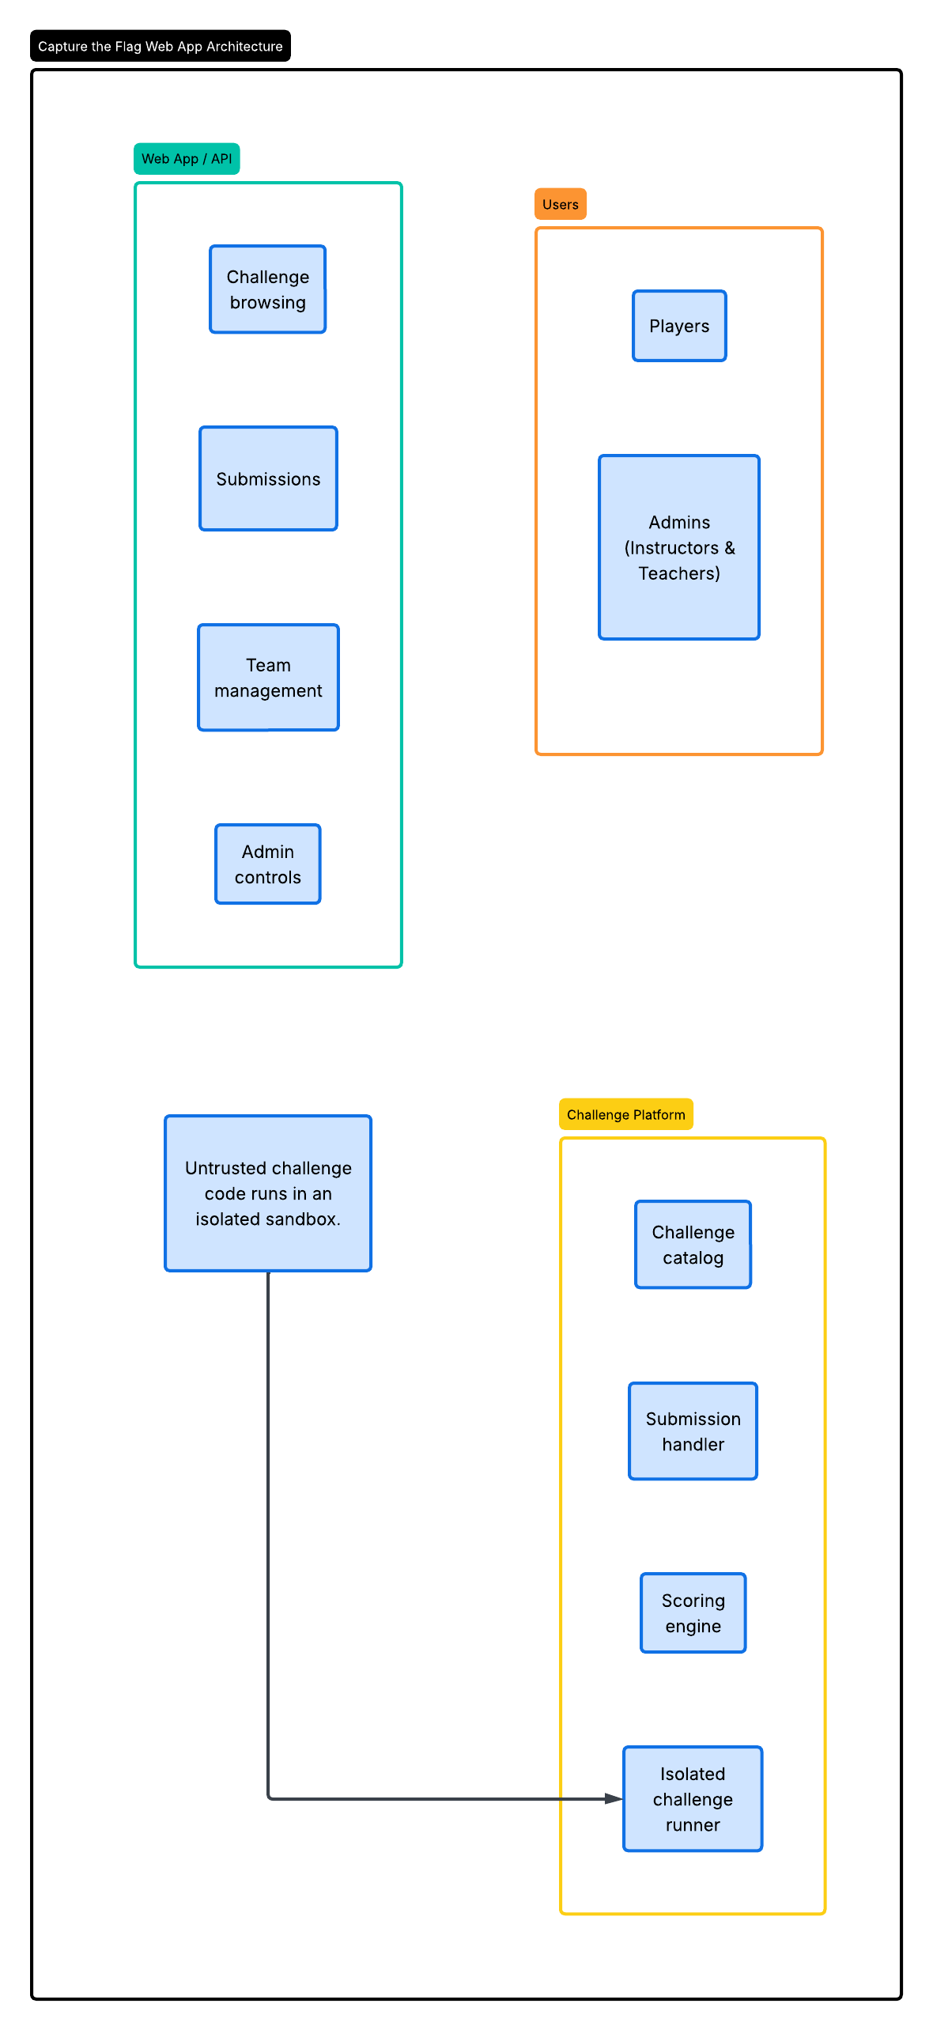
  - Web App / API layer: an Angular single-page app talks to a C# REST API over HTTPS. It covers challenge browsing, flag submissions, team management, and admin controls.
  - Users: two roles, Players and Admins (instructors and teachers). The UI and API both enforce role-based access, so each role sees a different view.
  - Challenge Platform: the challenge catalog, submission handler, scoring engine, and isolated challenge runner. These are separate modules inside the backend so they can be split into services later.
  - Sandboxing: untrusted challenge code always runs in an isolated container with no access to the database or internal network and with CPU, memory, and time limits. The web API only sends run requests and receives results.
  - Data and hosting: a relational database stores users, challenges, submissions, and scores. The API is stateless and runs behind a load balancer on cloud hosting, which supports the scalability and load balancing requirements above.
- Develop the data model
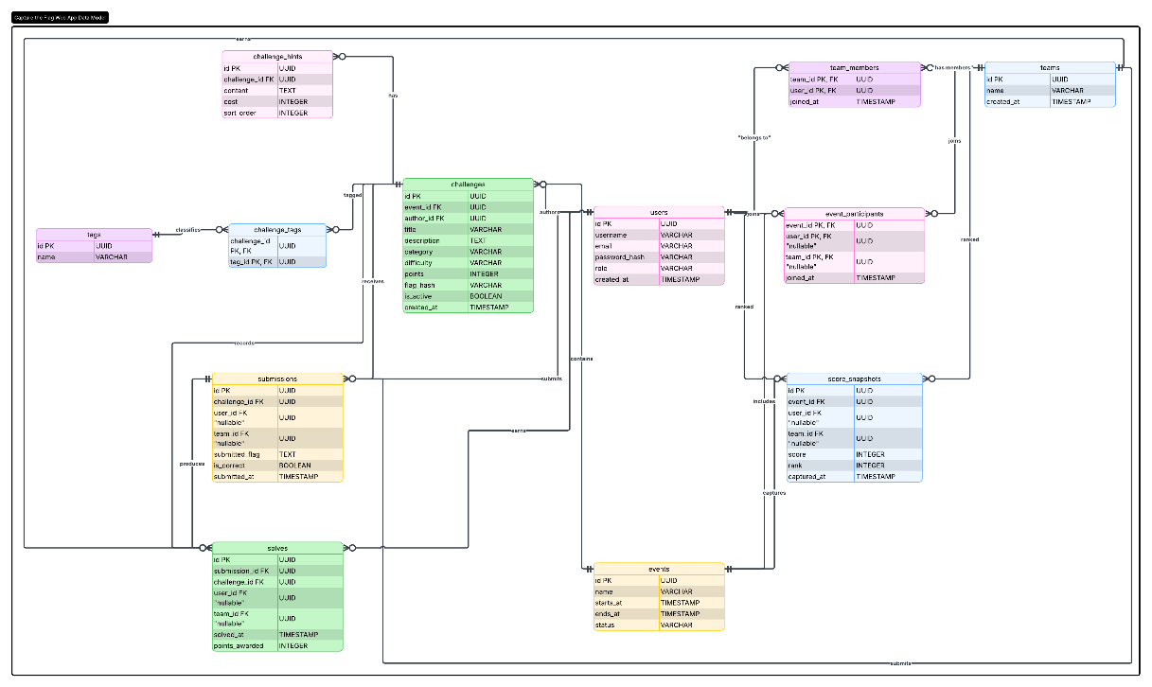
  - users, teams, team_members: accounts with a role (player, instructor, admin), and optional team membership.
  - events, event_participants: time-boxed competitions that users or teams join.
  - challenges, challenge_hints, challenge_tags, tags: challenge content. Flags are stored only as a hash (flag_hash), never in plain text.
  - submissions, solves: every flag attempt is recorded, and a correct attempt also creates a solve with the points awarded.
  - score_snapshots: point-in-time rankings per event, used by the leaderboards.
- Design User interfaces (UI); Optionally, design wireframes(on paper / on Figma / other tool)
Layout: a top navigation bar whose links depend on the signed-in role (Players see Challenges, Leaderboard, and Account; instructors also see Manage Challenges; admins also see Users). Wireframes for each screen below can be added here from Figma or paper sketches.
Screen | Users | Key elements
Login / Register | Everyone | Username or email and password fields, inline validation messages, sign-in and create-account buttons, link to reset password.
Challenge List | Players, Instructors, Admins | Cards or table of challenges with title, category, difficulty, points, and solved status; filters by category, difficulty, and tag; search box.
Challenge Detail / Run | Players | Description, hints (with point cost), challenge file download or Launch button, run output panel, flag input with Submit button and correct/incorrect feedback.
Event Leaderboard | Everyone signed in | Event selector, ranked table of user or team, score, and last solve time; highlights the current user.
Account Settings | Everyone signed in | Edit profile and password, submission history, and a Delete Account button with a confirmation dialog.
Manage Challenges | Instructors, Admins | List of challenges with edit and deactivate actions, plus an Add Challenge form (title, description, category, difficulty, points, flag, file upload, tags, hints).
User Management | Admins | Searchable user table with role dropdown, and disable or delete actions.

- Choose technology stack for implementation
Backend: C#
Frontend: Angular
API framework: ASP.NET Core Web API
Data access: Entity Framework Core
Database: PostgreSQL (matches the UUID and timestamp types in the data model)
Authentication: JWT bearer tokens, passwords hashed with ASP.NET Core Identity
Challenge sandbox: Docker containers with resource limits and no outbound network
Hosting: cloud provider (for example Azure) with a load balancer in front of the API
Testing: xUnit for the backend, Jasmine/Karma for the frontend
- Identify services and API endpoints
All endpoints validate input on the server (required fields, length and format checks, allowed values) and return 400 with error details when it fails. Protected endpoints require a valid JWT and check the user's role.
Auth service
Method | Endpoint | Description | Access
POST | /api/auth/register | Create an account | Public
POST | /api/auth/login | Verify credentials and return a token | Public
POST | /api/auth/logout | End the session | Signed in

Account service
Method | Endpoint | Description | Access
GET | /api/users/me | Get own profile | Signed in
PUT | /api/users/me | Update profile or password | Signed in
DELETE | /api/users/me | Delete own account | Signed in
GET | /api/users | List and search users | Admin
PUT | /api/users/{id}/role | Change a user's role | Admin
DELETE | /api/users/{id} | Delete a user | Admin

Challenge service
Method | Endpoint | Description | Access
GET | /api/events/{eventId}/challenges | List challenges for an event | Signed in
GET | /api/challenges/{id} | Get challenge details and hints (never the flag) | Signed in
GET | /api/challenges/{id}/file | Download the challenge file | Signed in
POST | /api/challenges | Add a challenge | Instructor, Admin
PUT | /api/challenges/{id} | Edit a challenge | Instructor, Admin
DELETE | /api/challenges/{id} | Deactivate a challenge | Instructor, Admin

Challenge runner service (sandbox)
Method | Endpoint | Description | Access
POST | /api/challenges/{id}/run | Start the challenge in an isolated container | Player
GET | /api/runs/{runId} | Get run status and output | Player
DELETE | /api/runs/{runId} | Stop and clean up the container | Player

Submission and scoring service
Method | Endpoint | Description | Access
POST | /api/challenges/{id}/submissions | Submit a flag; the server compares its hash, records the attempt, and awards points on a first correct solve | Player
GET | /api/users/me/submissions | Get own submission history | Signed in

Event and leaderboard service
Method | Endpoint | Description | Access
GET | /api/events | List events | Signed in
POST | /api/events | Create an event | Instructor, Admin
POST | /api/events/{id}/join | Join an event as a user or team | Player
GET | /api/events/{id}/leaderboard | Get ranked scores for an event | Signed in

Team service
Method | Endpoint | Description | Access
POST | /api/teams | Create a team | Player
POST | /api/teams/{id}/members | Add or invite a member | Team owner
DELETE | /api/teams/{id}/members/{userId} | Remove a member or leave the team | Team owner, member

